Robotics Process Automation Design and Development (UiPath) – BCG701 Lab
Experiment No: 4
Title: Develop UI automation in UiPath StudioX to demonstrate the following activities: Check App State, Click, Type Into, Select Item, Check/Uncheck, Get Text, Get Attribute, Extract Table Data, and Hover.

Aim: To develop an automation in UiPath StudioX to demonstrate the following activities:
- Application state verification
- Clicking elements
- Typing Input
- Selecting items from dropdowns
- Handling checkboxes
- Extracting text and attributes
- Retrieving structured data
- Performing mouse hover actions

Theory:
- Check App State: Verifies if a specific UI element (like a button, field, or application window) is available before proceeding. Used for conditional execution based on app readiness.
- Click: Simulates a mouse click on a specified UI element such as a button, link, or icon.
- Type Into: Enters text into an editable field, such as a search bar or form input box.
- Select Item: Chooses a value from a dropdown list or combo box.
- Check/Uncheck: Toggles the state of a checkbox (selects or deselects).
- Get Text: Extracts visible text from a UI element on the screen.
- Get Attribute: Retrieves metadata from a UI element, such as a hyperlink URL (href) or tooltip.
- Extract Table Data: Extracts structured tabular data from a webpage or application into a DataTable format for further processing.
- Hover: Moves the mouse pointer over a specific UI element without clicking, useful for revealing hidden menus or tooltips.

Conduction:
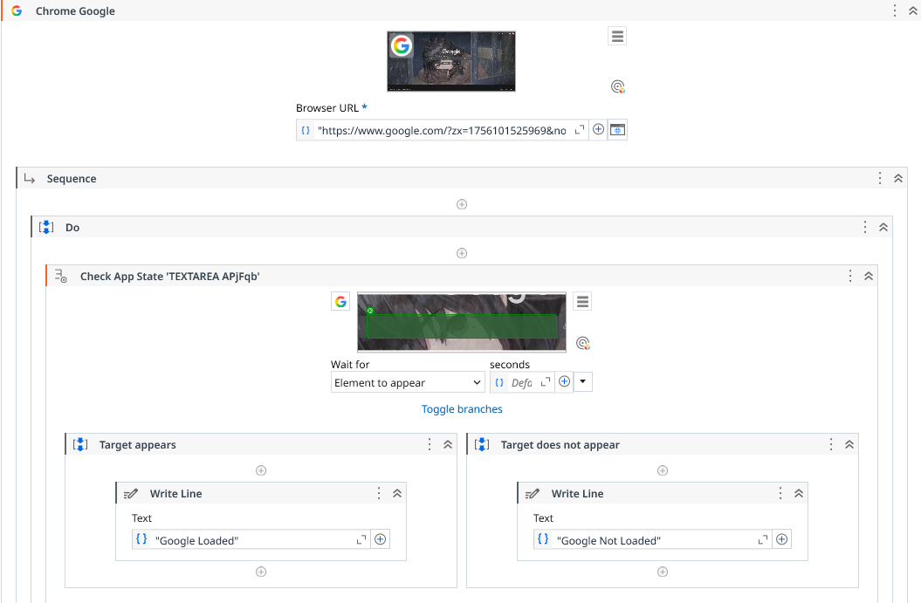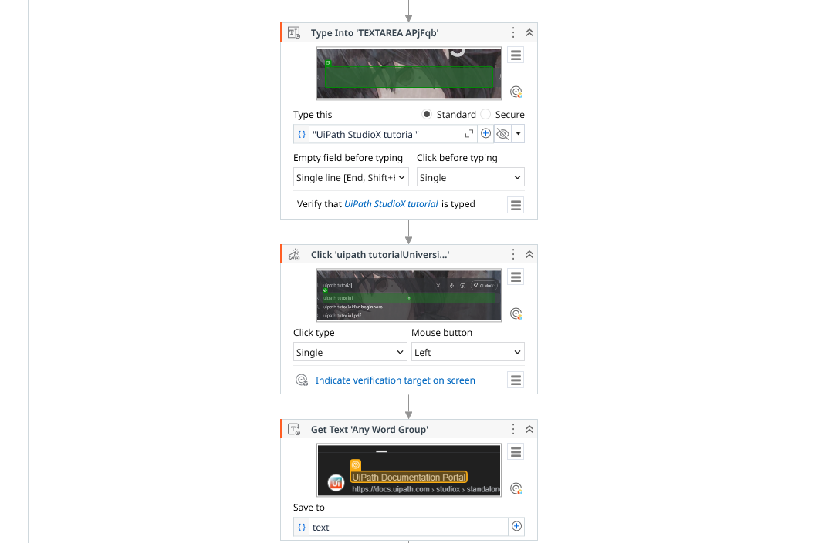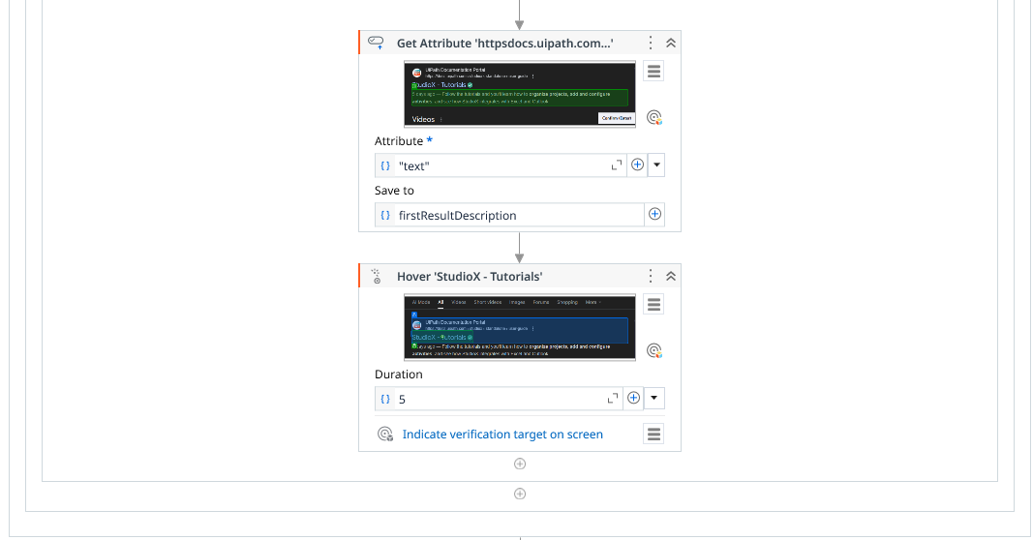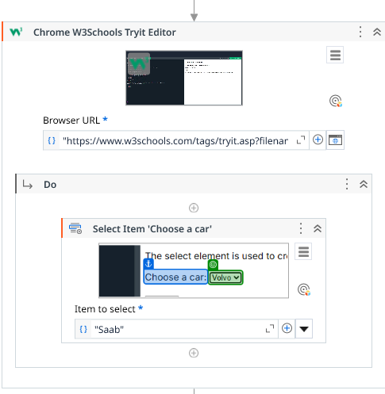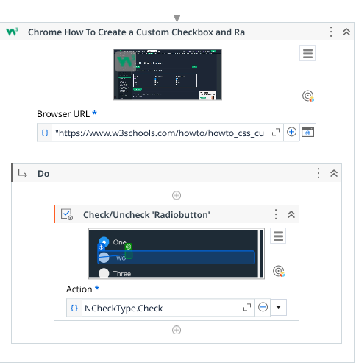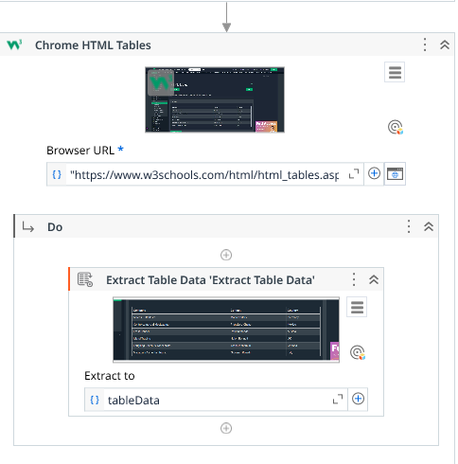
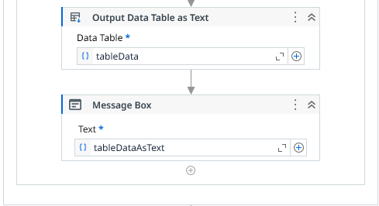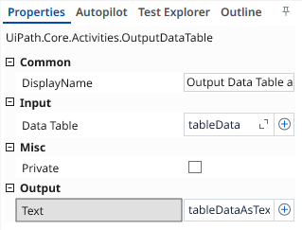
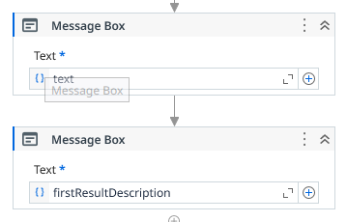

Output:
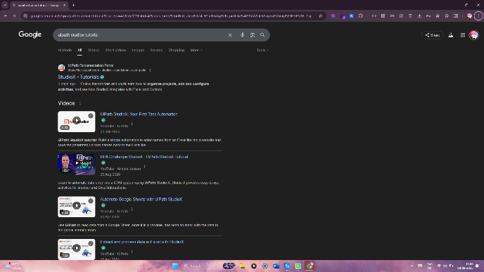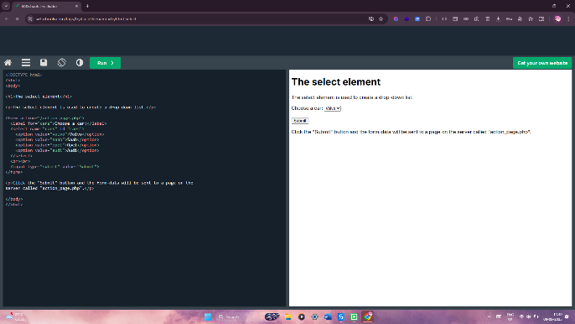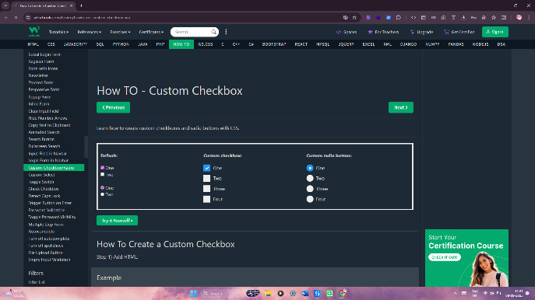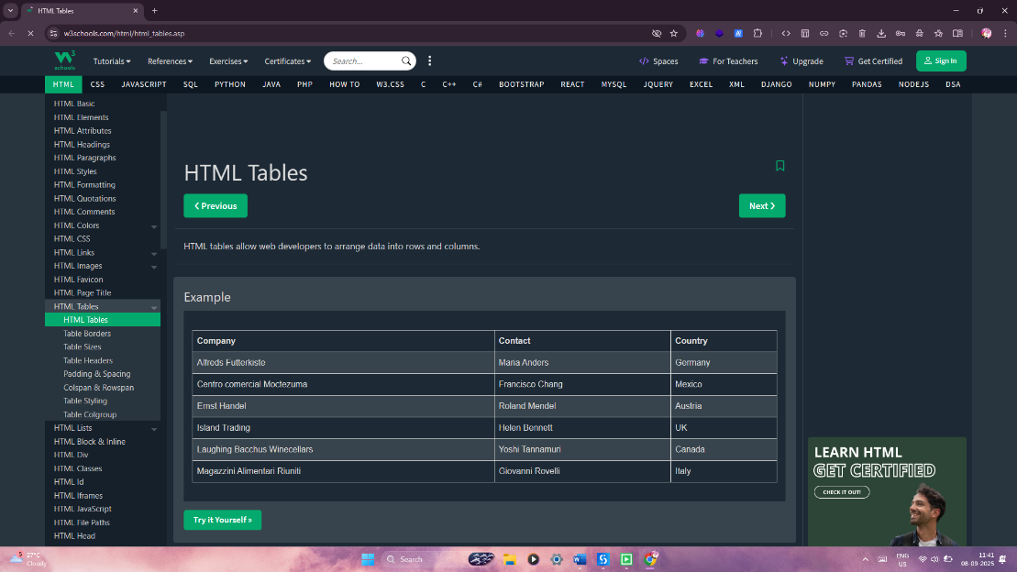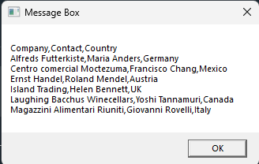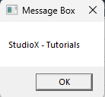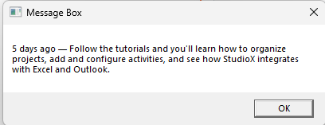

Observation and Results:
The following activities were successfully demonstrated in UiPath StudioX:
- Check App State
- Click
- Type Into
- Select Item
- Check/Uncheck
- Get Text
- Get Attribute
- Extract Table Data
- Hover

The output for the above-mentioned activities is verified.

Evaluation:
Evaluation Parameters | Maximum Marks | Obtained Marks
Conduction | 8
Record Writing | 4
Viva | 3
Total | 15

Signature of the Faculty in-charge with date:

